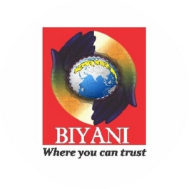

PHOTO

**EMPLOYABILITY TEST**

1. **BASIC DETAILS**

|  |  |
| --- | --- |
| Candidate Name |  |
| Father's Name |  |
| Stream |  |
| Class |  |
| Contact No. |  |
| Email id |  |
| Address |  |

1. **ACADEMIC DETAILS**

|  |  |  |  |  |
| --- | --- | --- | --- | --- |
| Class | Year | Board | Percentage | Place |
| 10th |  |  |  |  |
| 12th |  |  |  |  |
| Graduation |  |  |  |  |
| Post-Graduation |  |  |  |  |

1. **INTERNSHIP/ LIVE PROJECTS DETAILS**

|  |  |  |  |
| --- | --- | --- | --- |
| Company Name | Duration | Specialisation | Paid/Non-Paid |
|  |  |  |  |
|  |  |  |  |
|  |  |  |  |

1. **CONFERENCE/SEMINARS/WORKSHOP/TRAINING DETAILS**

|  |  |  |
| --- | --- | --- |
| Conference/seminar/workshop Name | Duration | Presented/attended/volunt. |
|  |  |  |
|  |  |  |
|  |  |  |

1. **INDUSTRIAL VISIT EXPOSURE**

|  |  |  |
| --- | --- | --- |
| Industry Name | Date | Place |
|  |  |  |
|  |  |  |
|  |  |  |

**LINKED IN ACCOUNT NAME:……………………………………………………………………………………………**

1. EVALUATION (FOR OFFICE USE ONLY)

|  |  |  |  |
| --- | --- | --- | --- |
| **Particulars** | **Ok** | **Not Ok** | **Obervation/suggestion** |
| Resume/CV |  |  |  |
| Communication Skill |  |  |  |
| Basic English |  |  |  |
| Grooming |  |  |  |
| Body Language |  |  |  |
| Dressing Sense |  |  |  |
| Awareness fo Indial Ethos |  |  |  |
| Computer Skills |  |  |  |
| Writing Skills |  |  |  |

MOS CERTIFICATION Yes No

Feedback……………………………………………………………………………………………………………….…………………………………………………………………………………………………………………………………..………………………………………………………………………………………………………………………....